CS 255 System Design Document Template

UML Diagrams

UML Use Case Diagram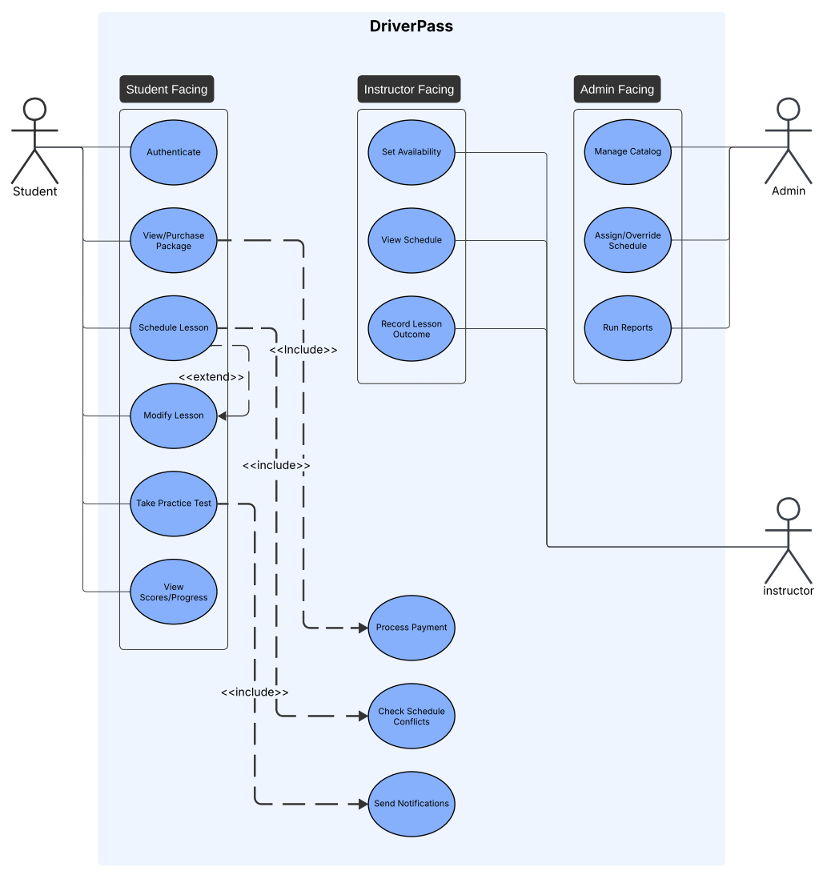

UML Activity Diagrams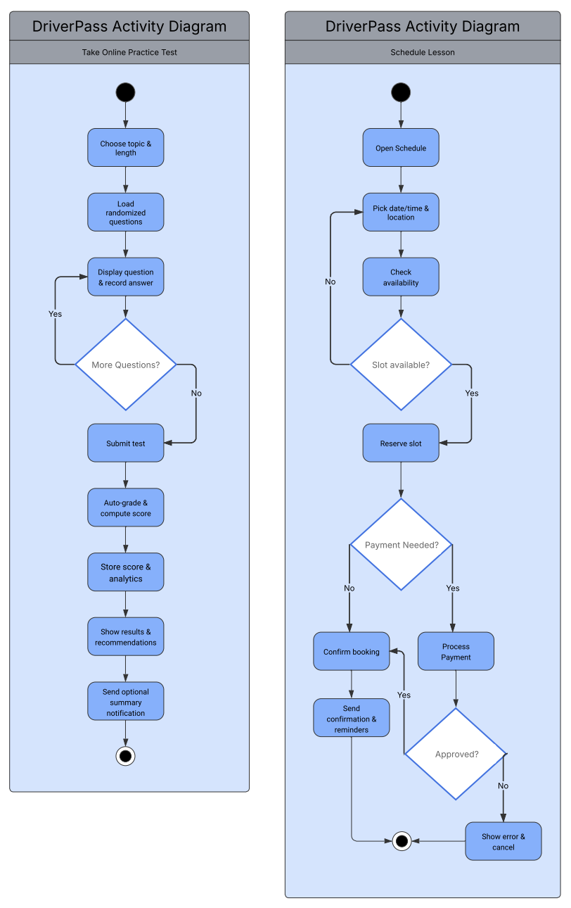

UML Sequence Diagram
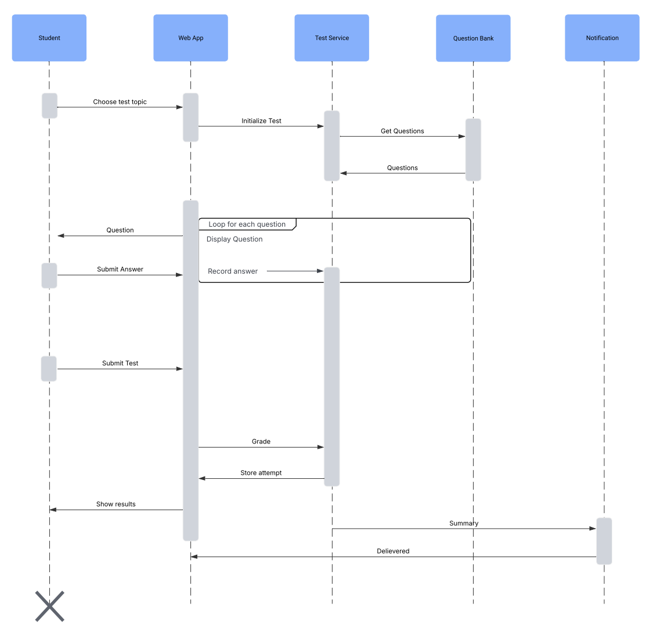

UML Class Diagram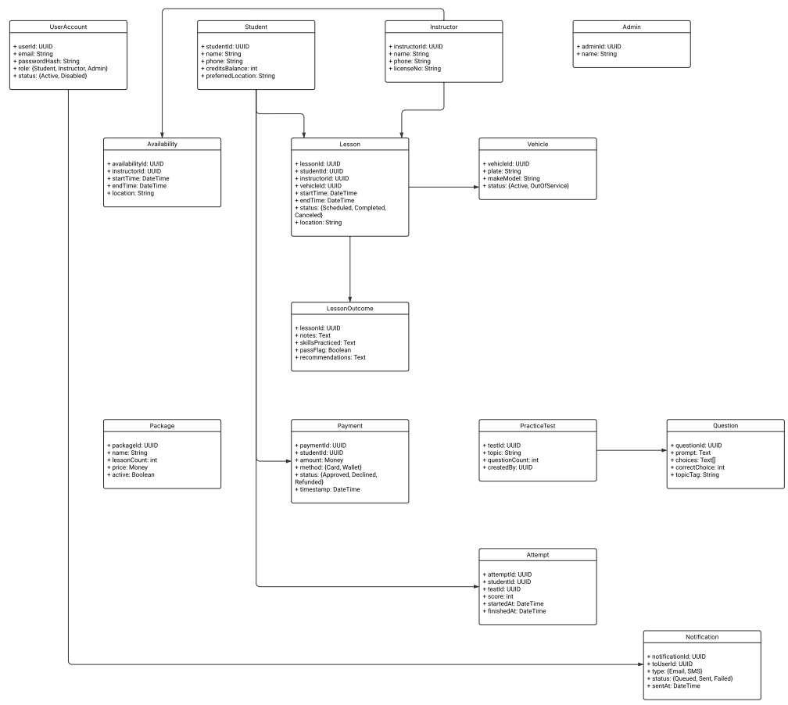

Technical Requirements
The DriverPass system will require the following in order to support online scheduling, practice testing and payment processing.

- A reliable web server hosted online to run the system.
- Secure backup system so data is safe.
- A database server to store information.
- Web framework.
- Database tool to help manage lessons, users.
- SSL encryption so data moves back and forth securely.
- Login and roles.
- Payment service.

